Season Ticket Renewal Prediction Report
David Mullaly
2026-02-20

Data Loading and Wrangling
Load four relational tables and merge into a single flat file (FFdf) using left joins on Cust_ID.
## MainDF: 9447 48 | StoreDF: 9272 3 | ConcessDF: 9272 3 | CustomerDF: 14272 7
## Duplicates in MainDF: 175
## Duplicates in StoreDF: 0
## Duplicates in ConcessDF: 0
## Duplicates in CustomerDF: 0
## Final flat file dimensions - Rows: 9447 Columns: 58
## Unique Cust_ID: 9272 | Duplicate rows: 175

Step 1: Open Data in Your Software of Choice
Create identifier variable, arrange columns, and explore distributions visually.
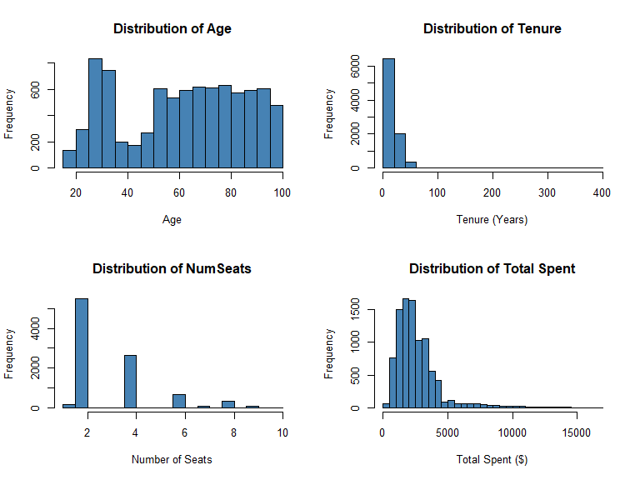
## Response Variable (Y01): 2196 7251
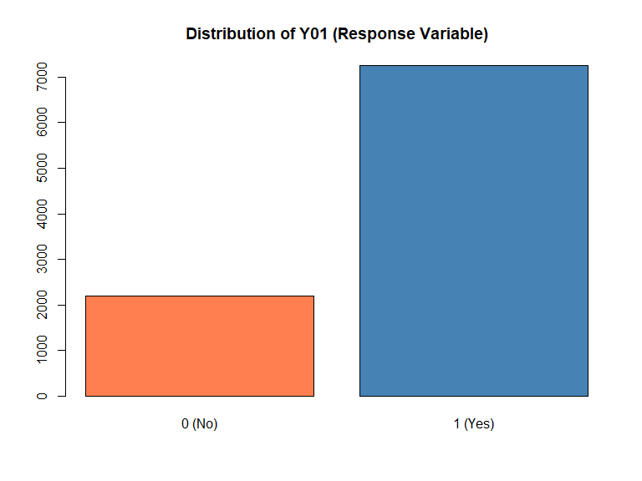
Observations: Age is roughly normal (30-60), Tenure is right-skewed, NumSeats clusters around 2-4, Total Spent is heavily right-skewed. Response variable Y01 is reasonably balanced.

Step 2: Review Variables for Common Sense (SME Knowledge)
Standardize variable names and check for unique identifiers.
## Dataset: 9447 rows, 59 columns
## Unique Cust_ID: 9272 out of 9447 rows
Result: Each row does not necessarily represent a unique customer (175 duplicate Cust_IDs found in MainDF source data).

Step 3: Review How Software Coded Variables
Convert character variables to factors for proper categorical analysis.
## Character variables to convert: 23
##
## Sex levels: F M
## Marital levels: D M S U
## Account_Type levels: Business Personal Shared
Note: Marital has levels D (Divorced), M (Married), S (Single), U (Unknown). The “U” for Unknown may need special handling.

Step 4: Data Integrity/Validation Checks
Check for anomalies, bogus values, and data quality issues.
## Age range: 18 99
## Tenure range: 1 400
## NumSeats range: 1 10
##
## DistA values = 999: 1506
## DistA NA count after conversion: 2895
##
## Survey_Comp range: 0 7.4
## Survey_Comp values > 1: 110
##
## State_Name unique: 50 | State_Loc unique: 50
Issues Found:
- DistA = 999: Placeholder values converted to NA
- Survey_Comp > 1: Outlier found when expected range is 0-1
- Age max = 99: May be placeholder or extreme value - verify with SME
- Tenure max = 400: Suspicious value if measured in years - verify units with SME
- State_Name/State_Loc: Redundant columns (same info, different format)
- Marital = “U”: Unknown status - consider treating as NA
- Cust_ID duplicates: 175 duplicate IDs found in MainDF source data
- Address, Name, PhoneNum: 100% missing - likely removed from CustomerDF for privacy

Step 5: Handle Dates
Convert Last_Contact datetime and extract useful components.
## Date components extracted: Contact_Year, Contact_Month, Contact_Day, Contact_Weekday, Contact_Hour
## Contact Year range: 2018 2025
## Contact Hour range: 0 23

Summary
## Final Dataset: 9447 rows x 64 columns
## Total Missing Values: 94591
##
## Columns with missing values:
## Address Name PhoneNum
## 9447 9447 9447
## Educational_Level Favorite_Caps_Player Favorite_Sport
## 6612 6612 6612
## Job_Sector Mode_Of_Transport Team_B_STH
## 6612 6612 6612
## Team_C_STH Net_Worth_True HouseHold_Income_True
## 6612 5762 5691
## DistA Marital Age
## 2895 1155 986
## Rep_Name Sex Tenure
## 871 667 592
## Rep_Visits Rep_Calls Num_Children
## 508 433 406

Data Quality Issues for Future Steps:
Issue | Possible action / Action Taken
DistA = 999 | Converted to NA
Survey_Comp > 1 | Flag for investigation (110 values, max 7.4)
Age = 99 | Verify with SME
Tenure = 400 | Verify units with SME (400 years unlikely)
Marital = “U” | Consider as NA or keep
State redundancy | Drop one column
ID columns | Exclude from modeling
Cust_ID duplicates | 175 duplicates in MainDF - investigate or deduplicate
PII columns | Address, Name, PhoneNum 100% missing - exclude
Step 6: Handle Categorical Variables - keep as is, combine rare levels, combine similar levels
## Factor variables: 23
##
## Variables with rare levels (< 5%):
## [1] "Educational_Level" "Favorite_Caps_Player" "Favorite_Sport"
## [4] "Favorite_Team" "Job_Sector" "Marital"
## [7] "Mode_Of_Transport" "Most_Purch_Concession" "Mult_Loc"
## [10] "Rep_Name" "Seating_Location" "State_Loc"
## [13] "State_Name"
##
## --- Sex Distribution ---
##
## F M <NA>
## 1078 7702 667
##
## --- Marital Distribution ---
##
## D M S U <NA>
## 908 6227 909 248 1155
##
## --- Account_Type Distribution ---
##
## Business Personal Shared
## 1057 7462 928
##
## --- Educational_Level Distribution ---
##
## AD BD HS MD PHD SC <NA>
## 450 827 547 313 237 461 6612
## Marital 'U' (Unknown) count: 248
## Decision: Keep 'U' as separate level for now - may represent meaningful unknown status
##
## --- State_Name levels ---
## [1] 50
## Number of unique states: 50
## === LUMPING RARE LEVELS (< 5%) INTO 'Other' ===
## Favorite_Sport: 8 -> 2 levels
##
## NHL Other <NA>
## 1996 839 6612
##
## Favorite_Team: 25 -> 4 levels
##
## New Jersey Devils Philadelphia Flyers Washington Capitals Other
## 788 856 6632 1171
##
## Mode_Of_Transport: 5 -> 4 levels
##
## Car Public Uber/Taxi Other <NA>
## 1104 905 603 223 6612
##
## Most_Purch_Concession: 9 -> 8 levels
##
## Beer Burger Hot Dog Peanuts Popcorn Soda Specialty Other
## 2294 955 1422 474 1387 1425 977 513
##
## Rep_Name: 9 -> 7 levels
##
## Alice David Emma Frank Grace Ivy Other <NA>
## 823 1798 1538 1942 952 959 564 871
## Lumping complete.
## --- Region Distribution (grouped from State_Name) ---
##
## DCArea Midwest Northeast South West
## 4842 551 1703 1856 495
##
## Region percentages:
##
## DCArea Midwest Northeast South West
## 51.25 5.83 18.03 19.65 5.24
##
## All states successfully mapped to regions.
Step 6 Observations:
- Marital has “U” (Unknown) level - kept as separate category for now
- Educational_Level could be made ordinal if needed for certain models
- State_Name grouped into US regions - reduces cardinality from 50 levels to 5 (Northeast, Midwest, South, West, DCArea)
- Rare levels (< 5%) lumped into “Other” using fct_lump_prop() for all applicable factor variables

Step 7: Remove Zero-Variance Predictors
## Zero-variance columns found: 8
## Columns with zero variance:
## [1] "Address" "InfRate" "Last_Team_Championship"
## [4] "Name" "NHL_Team_Record" "PhoneNum"
## [7] "Playoffs" "UnempRate"
##
## Removed 8 zero-variance columns
## Remaining columns: 58
Step 7 Results:
The following 8 zero-variance columns were identified and removed:
- Address, Name, PhoneNum: PII columns - 100% missing (intentionally scrubbed)
- InfRate, UnempRate: Economic indicators - likely constant for this snapshot
- Last_Team_Championship, NHL_Team_Record, Playoffs: Team-related constants
These columns provide no predictive value since every observation has the same value (or all NA).

Class 4: Data Cleaning Process: Steps 8-11
Step 8: Handle Near Zero-Variance Predictors
## Near-zero variance columns (>95% one value):
## Variable DominantValue DominantPct UniqueValues
## 1 Additional_Seats 0 96.99 12
## 2 Mult_Loc No 96.99 2
## Near-zero variance variables to monitor:
## [1] "Additional_Seats" "Mult_Loc"
##
## Decision: Keep for now but flag for potential exclusion during modeling
Step 8 Results:
Near-zero variance columns identified (>95% one value):
Variable | Dominant Value | Dominant %
Additional_Seats | 0 | 96.99%
Mult_Loc | No | 96.99%
Observations:
- Additional_Seats: 97% of customers have 0 additional seats - consider binning (0 vs >0)
- Mult_Loc: 97% are “No” - low information but may still be predictive for the 3% minority
- Decision: Keep for now but flag for potential exclusion during modeling
- May cause issues with some modeling techniques (especially regression-based)

Step 9: Remove Redundant Columns and Linear Combination Columns
## --- Checking State_Name vs State_Loc redundancy ---
## State_Name unique values: 50
## State_Loc unique values: 50
##
## Decision: State_Name and State_Loc appear to be the same information.
## Removing State_Loc (keeping State_Name)
##
## --- Highly correlated variable pairs (|r| > 0.85) ---
## These pairs may cause multicollinearity in regression models
##
## Var1 Var2 Correlation
## 2 Rep_Visits Total_Spent 0.947
## 4 Weekday_Attended Weekday_Sold -0.946
## 1 Concession_Total NumSeats 0.915
## 3 Team_Store_Total Total_Spent 0.853
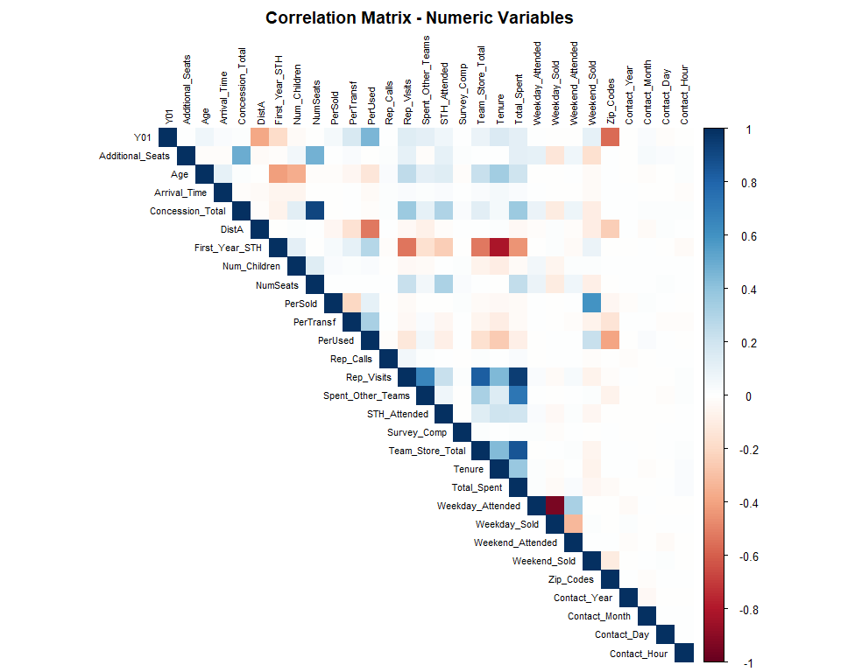
## === MULTICOLLINEARITY ANALYSIS ===
## Cluster 1: Spending & Visit variables
## - Rep_Visits <-> Total_Spent: r = 0.947 (very strong positive)
## - Team_Store_Total <-> Total_Spent: r = 0.853 (strong positive)
## Recommendation: Consider removing Rep_Visits or Total_Spent
## Cluster 2: Concession & Seating
## - Concession_Total <-> NumSeats: r = 0.915 (strong positive)
## Recommendation: Makes business sense - more seats = more concessions
## Cluster 3: Attendance pairs
## - Weekday_Attended <-> Weekday_Sold: r = -0.946 (strong NEGATIVE)
## Note: Negative correlation suggests inverse relationship
## Recommendation: Keep both - they capture different behaviors
## Variables flagged for potential removal due to multicollinearity:
## [1] "Rep_Visits" "Team_Store_Total"
##
## Decision: Flag but keep for now; remove during modeling if VIF > 10
Step 9 Observations:
Based on the correlation matrix analysis (actual results from output above):
Cluster | Variables | Correlation | Recommendation
1 | Rep_Visits vs Total_Spent | r = 0.947 | Remove Rep_Visits
1 | Team_Store_Total vs Total_Spent | r = 0.853 | Monitor for VIF
2 | Concession_Total vs NumSeats | r = 0.915 | Keep - business logic
3 | Weekday_Attended vs Weekday_Sold | r = -0.946 | Keep both - inverse relationship
- | State_Loc vs State_Name | Redundant | REMOVED
Action Items: - State_Loc removed (redundant with State_Name) - Flagged 2 variables for potential removal: Rep_Visits, Team_Store_Total - Will check VIF during modeling phase and remove if VIF > 10

Step 10: Search for Outliers and Initial Search for Missing Values
## Age outliers (IQR method): 0 values
## Tenure outliers: 8 values | Max: 400
## Survey_Comp values > 1: 110
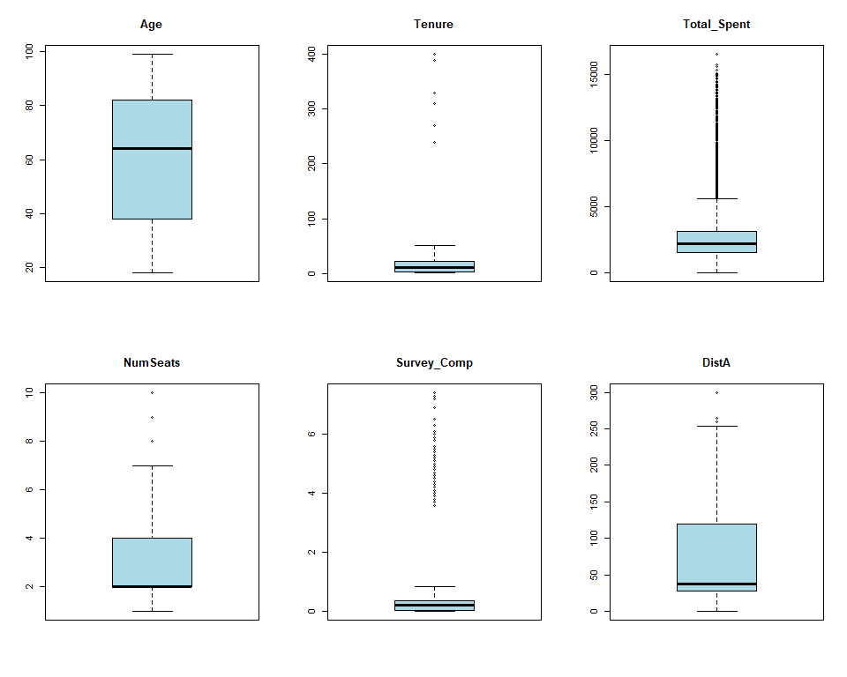
## === MISSING DATA ASSESSMENT ===
## Total missing values: 67405 out of 538479 ( 12.52 %)
## Columns with missing values:
## Variable Missing_Count Missing_Pct
## 1 Educational_Level 6612 69.99
## 2 Favorite_Caps_Player 6612 69.99
## 3 Favorite_Sport 6612 69.99
## 4 Job_Sector 6612 69.99
## 5 Mode_Of_Transport 6612 69.99
## 6 Team_B_STH 6612 69.99
## 7 Team_C_STH 6612 69.99
## 8 Net_Worth_True 5762 60.99
## 9 HouseHold_Income_True 5691 60.24
## 10 DistA 2895 30.64
## 11 Marital 1155 12.23
## 12 Marital_Original 1155 12.23
## 13 Age 986 10.44
## 14 Rep_Name 871 9.22
## 15 Sex 667 7.06
## 16 Tenure 592 6.27
## 17 Rep_Visits 508 5.38
## 18 Rep_Calls 433 4.58
## 19 Num_Children 406 4.30
##
## === OUTLIER DECISIONS ===
## 1. Tenure max = 400:
## - If measured in years, this is impossible
## - May be measured in months (400 months = 33 years - plausible)
## - ACTION: Verify units with SME; flag for review
## 2. Age = 99:
## - Could be real (elderly customer) or placeholder
## - ACTION: Verify with SME; consider if 99 is data entry default
## 3. Survey_Comp values > 1 (expected 0-1 range):
## - Count: 110
## - Max value: 7.4
## - ACTION: Possible scale issue; cap at 1 or investigate data source
## Created outlier flag variables: Flag_Tenure_High, Flag_Survey_Invalid

Step 11: Sanity Check Using Decision Tree (1 to 2 splits)
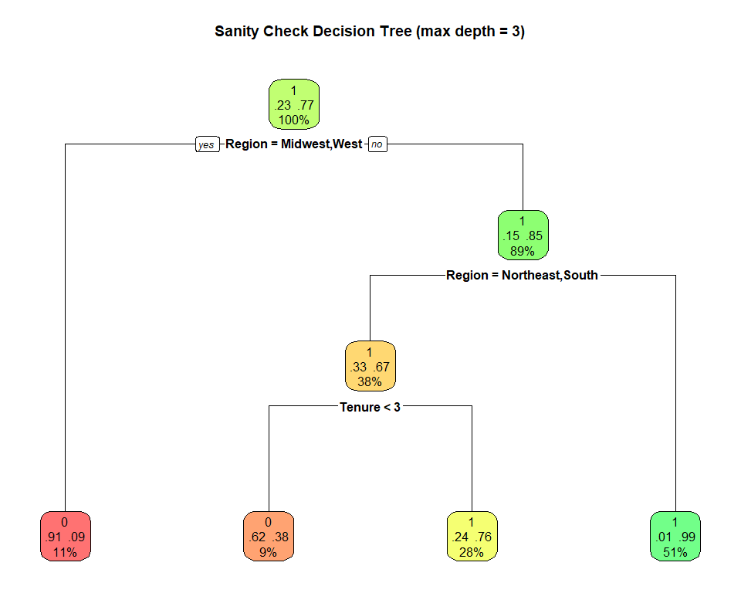
##
## === VARIABLE IMPORTANCE ===
## Region Favorite_Team PerUsed DistA
## 1505.21434 253.50828 245.18919 196.77674
## Tenure First_Year_STH Rep_Name Rejoined_STH
## 187.73632 125.59980 80.93227 50.19569
## Team_Store_Total PerTransf
## 26.31404 21.05856
##
## === SANITY CHECK ANALYSIS ===
## Tree accuracy: 88.11 %
## Accuracy is reasonable - no obvious data leakage detected
Step 11 Results:
The decision tree uses Region (from Step 6) instead of raw State_Name/Zip_Codes to avoid overfitting from high-cardinality variables.
Top Variable Importance:
Variable | Importance
Region | 1505.2
Favorite_Team | 253.5
PerUsed | 245.2
DistA | 196.8
Tenure | 187.7
Analysis:
- Accuracy ~88% - reasonable, no obvious data leakage
- Region is the dominant predictor - geographic location strongly predicts Y01
- No high-cardinality variables causing artificial inflation of accuracy

Summary of Steps 6-11 (Data Cleaning Complete)
## === DATA CLEANING SUMMARY (Steps 6-11) ===
## Step 6 - Handle Categorical Variables:
## - Rare factor levels (< 5%) lumped into 'Other' via fct_lump_prop()
## - Marital 'U' kept as separate category
## - State_Name grouped into US Census regions
## Step 7 - Zero-Variance Predictors:
## - Columns removed: 8
## Step 8 - Near Zero-Variance Predictors:
## - Variables flagged: 2
## - Decision: Keep for now but monitor during modeling
## Step 9 - Redundant Columns:
## - State_Loc removed (redundant with State_Name)
## - Correlation matrix reviewed for multicollinearity
## Step 10 - Outliers & Missing Data:
## - Total missing values: 67997
## - Outlier flags created for Tenure and Survey_Comp
## - Missing data summary table generated
## Step 11 - Decision Tree Sanity Check:
## - Tree accuracy: 88.11 %
## - Review variable importance for potential data leakage
## Final dataset dimensions: 9447 rows x 59 columns
##
## Cleaned dataset saved to: FFdf_cleaned.csv

Issues Identified for Further Action:
Step | Issue | Recommendation
6 | Marital “U” unknown | Keep as category or convert to NA during imputation
6 | Rare factor levels (< 5%) | RESOLVED: Lumped into “Other” via fct_lump_prop()
6 | State_Name high cardinality | RESOLVED: Grouped into US Census regions
7 | Zero-variance columns | Removed from dataset
8 | Near-zero variance | Monitor during modeling; consider binning
9 | State_Loc redundant | Removed
10 | Tenure = 400 | Verify units with SME (years vs months?)
10 | Survey_Comp > 1 | Investigate scale/cap values at 1
10 | Missing data patterns | Address in Missing Data phase (Class 5+)
11 | Tree predictors | RESOLVED: Using Region variable instead of State_Name

Missing Data Analysis: Steps 1-6

MD Step 1: Identify Missing Data
Rename to MDdf and count all missing values by variable.
MDdf <- FFdf
missing_summary <- data.frame(
Variable = names(MDdf),
Missing_Count = colSums(is.na(MDdf)),
Missing_Pct = round(colSums(is.na(MDdf)) / nrow(MDdf) * 100, 1)
) %>% filter(Missing_Count > 0) %>% arrange(desc(Missing_Count))
cat("Total missing:", sum(is.na(MDdf)), "of", nrow(MDdf)*ncol(MDdf), "cells (",
round(sum(is.na(MDdf))/(nrow(MDdf)*ncol(MDdf))*100,1), "%)\n")
## Total missing: 67997 of 557373 cells ( 12.2 %)
flextable(missing_summary) %>%
set_header_labels(Variable="Variable", Missing_Count="Missing (n)", Missing_Pct="Missing (%)") %>%
autofit()
Variable | Missing (n) | Missing (%)
Educational_Level | 6,612 | 70.0
Favorite_Caps_Player | 6,612 | 70.0
Favorite_Sport | 6,612 | 70.0
Job_Sector | 6,612 | 70.0
Mode_Of_Transport | 6,612 | 70.0
Team_B_STH | 6,612 | 70.0
Team_C_STH | 6,612 | 70.0
Net_Worth_True | 5,762 | 61.0
HouseHold_Income_True | 5,691 | 60.2
DistA | 2,895 | 30.6
Marital | 1,155 | 12.2
Marital_Original | 1,155 | 12.2
Age | 986 | 10.4
Rep_Name | 871 | 9.2
Sex | 667 | 7.1
Tenure | 592 | 6.3
Flag_Tenure_High | 592 | 6.3
Rep_Visits | 508 | 5.4
Rep_Calls | 433 | 4.6
Num_Children | 406 | 4.3
Observations:
- 12.2% overall missing; 7 CustomerDF variables (Educational_Level, Favorite_Caps_Player, Favorite_Sport, Job_Sector, Mode_Of_Transport, Team_B_STH, Team_C_STH) all missing at exactly 70%, likely a block from customers who skipped a supplemental survey.
- Net_Worth_True (61%) and HouseHold_Income_True (60%) are high, sensitive financial fields.
- DistA (30.6%) includes 999-placeholder NAs converted in Step 4.
- Moderate missingness (5–15%): Marital, Age, Rep_Name, Sex, Tenure, Rep_Visits, Rep_Calls, Num_Children.

MD Step 2: Mark Missing Data
Create binary indicator variables (M_VarName: 1 = missing, 0 = present) for all variables with NAs. Indicators allow MCAR/MAR testing and preserve pre-imputation missingness structure.
vars_with_na <- names(MDdf)[colSums(is.na(MDdf)) > 0]
vars_with_na <- vars_with_na[!vars_with_na %in% c("Marital_Original", "Flag_Tenure_High")]
for(var in vars_with_na) {
MDdf[[paste0("M_", var)]] <- ifelse(is.na(MDdf[[var]]), 1, 0)
}
indicator_vars <- grep("^M_", names(MDdf), value = TRUE)
cat("Indicator variables created:", length(indicator_vars), "\n")
## Indicator variables created: 18
# Correlation of indicators — high r = missing as a block
indicator_matrix <- MDdf[, indicator_vars]
indicator_matrix <- indicator_matrix[, sapply(indicator_matrix, stats::var) > 0]
cor_indicators <- cor(indicator_matrix)
corrplot(cor_indicators, method = "color", type = "upper",
tl.cex = 0.7, tl.col = "black",
title = "Correlation of Missing Data Indicators",
mar = c(0, 0, 2, 0))
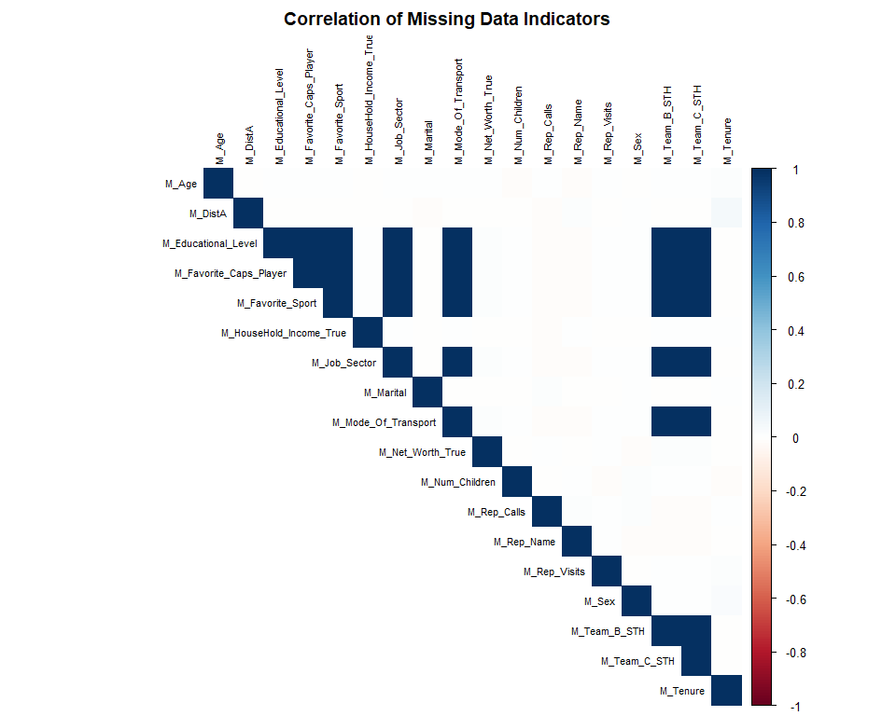
Observations:
- The 7 CustomerDF block variables have perfect indicator correlation (r = 1.0), confirming they are missing together.
- Net_Worth_True and HouseHold_Income_True indicators are moderately correlated missing together as financial fields.

MD Step 3: Clean Up Obvious Mistakes
Fix values that are wrong or that should be coded as NA.
# Survey_Comp > 1: cap at 1.0 (proportion cannot exceed 100%)
cat("Survey_Comp > 1 count:", sum(MDdf$Survey_Comp > 1, na.rm = TRUE), "| max:", max(MDdf$Survey_Comp, na.rm = TRUE), "\n")
## Survey_Comp > 1 count: 110 | max: 7.4
MDdf$Survey_Comp[MDdf$Survey_Comp > 1] <- 1.0
cat("Survey_Comp after cap:", range(MDdf$Survey_Comp, na.rm = TRUE), "\n\n")
## Survey_Comp after cap: 0 1
# Marital "U": keep as valid level — unknown status is informative
cat("Marital 'U' count:", sum(MDdf$Marital == "U", na.rm = TRUE), "— KEPT as distinct level\n")
## Marital 'U' count: 248 — KEPT as distinct level
cat("Marital true NAs:", sum(is.na(MDdf$Marital)), "\n\n")
## Marital true NAs: 1155
# Tenure / Age extremes: flag only, leave for SME
cat("Tenure > 100:", sum(MDdf$Tenure > 100, na.rm = TRUE), "| Age == 99:", sum(MDdf$Age == 99, na.rm = TRUE), "— flagged, left as-is\n")
## Tenure > 100: 8 | Age == 99: 111 — flagged, left as-is
cat("Total missing after cleanup:", sum(is.na(MDdf)), "\n")
## Total missing after cleanup: 67997
Observations:
- Survey_Comp: 110 values capped at 1.0 (data entry errors on a 0–1 proportion scale).
- Marital “U” (248 values): kept, preserves information, lets model treat “Unknown” as its own category. True NAs still go to MICE.
- Tenure = 400 / Age = 99: left pending SME confirmation of units.

MD Step 4: Make Easy Decisions on Rows/Columns
Define which columns are excluded from imputation (non-analytical only). No rows excluded. All variables with missing data — including the 70% block — are imputed.
id_cols <- c("ID", "Cust_ID")
backup_cols <- c("Marital_Original", "Flag_Tenure_High", "Flag_Survey_Invalid")
date_cols <- c("Last_Contact","Contact_Year","Contact_Month","Contact_Day","Contact_Weekday","Contact_Hour")
high_card_cols <- c("State_Name", "Zip_Codes", "Seating_Location")
indicator_cols <- grep("^M_", names(MDdf), value = TRUE)
all_exclude <- c(id_cols, backup_cols, date_cols, high_card_cols, indicator_cols)
impute_vars <- names(MDdf)[!names(MDdf) %in% all_exclude]
impute_with_na <- impute_vars[colSums(is.na(MDdf[, impute_vars])) > 0]
cat("Columns excluded from imputation:", length(all_exclude), "\n")
## Columns excluded from imputation: 32
cat("Imputation-eligible variables:", length(impute_vars), "| with NAs:", length(impute_with_na), "\n\n")
## Imputation-eligible variables: 45 | with NAs: 18
# Row missing summary
row_na <- rowSums(is.na(MDdf[, impute_vars]))
cat("Row NA distribution among eligible columns:\n")
## Row NA distribution among eligible columns:
cat(" 0 missing:", sum(row_na == 0), "| 1-3:", sum(row_na >= 1 & row_na <= 3),
"| 4-6:", sum(row_na >= 4 & row_na <= 6), "| 7+:", sum(row_na > 6), "\n")
## 0 missing: 168 | 1-3: 2370 | 4-6: 296 | 7+: 6613
cat("Decision: No rows excluded.\n")
## Decision: No rows excluded.
Observations:
- Excluded: ID/Cust_ID, derived backup/flag columns, date components, high-cardinality cols (State_Name, Zip_Codes, Seating_Location), all M_ indicators.
- All variables with missing data are kept for imputation, including the 70% block, to observe the full effect on modeling.

MD Step 5: Assess Missingness Patterns (MCAR vs MAR)
Use decision trees predicting each variable’s M_ indicator. If the tree finds splits, missingness is predictable from other data → MAR. No splits → likely MCAR.
predictor_candidates <- impute_vars[colSums(is.na(MDdf[, impute_vars])) == 0]
complete_predictors <- MDdf[, predictor_candidates]
# Drop high-cardinality factors and logical columns
complete_predictors <- complete_predictors[, sapply(complete_predictors, function(x)
!(is.factor(x) && nlevels(x) > 30))]
complete_predictors <- as.data.frame(lapply(complete_predictors, function(x)
if(is.logical(x)) as.integer(x) else x))
results <- data.frame(Variable=character(), Splits=integer(), Accuracy=numeric(),
Top_Predictor=character(), Assessment=character(), stringsAsFactors=FALSE)
for(var in impute_with_na) {
target <- factor(MDdf[[paste0("M_", var)]], levels=c(0,1), labels=c("Present","Missing"))
tree_data <- cbind(Target=target, complete_predictors)
tree_model <- rpart(Target ~ ., data=tree_data, method="class",
control=rpart.control(maxdepth=3, minsplit=50, cp=0.01))
n_splits <- nrow(tree_model$frame[tree_model$frame$var != "<leaf>", ])
acc <- round(mean(predict(tree_model, tree_data, type="class") == target) * 100, 1)
top_pred <- if(length(tree_model$variable.importance) > 0) names(tree_model$variable.importance)[1] else "None"
assessment <- if(n_splits == 0) "Likely MCAR" else if(acc > 85) "MAR" else "Possibly MAR"
results <- rbind(results, data.frame(Variable=var, Splits=n_splits, Accuracy=acc,
Top_Predictor=top_pred, Assessment=assessment,
stringsAsFactors=FALSE))
}
flextable(results) %>%
set_header_labels(Variable="Variable", Splits="Splits", Accuracy="Accuracy (%)",
Top_Predictor="Top Predictor", Assessment="Assessment") %>%
color(~ Assessment == "MAR", ~ Assessment, color="red") %>%
color(~ Assessment == "Likely MCAR", ~ Assessment, color="darkgreen") %>%
color(~ Assessment == "Possibly MAR",~ Assessment, color="orange") %>%
autofit()
Variable | Splits | Accuracy (%) | Top Predictor | Assessment
Age | 0 | 89.6 | None | Likely MCAR
DistA | 5 | 86.7 | Y01 | MAR
Educational_Level | 0 | 70.0 | None | Likely MCAR
Favorite_Caps_Player | 0 | 70.0 | None | Likely MCAR
Favorite_Sport | 0 | 70.0 | None | Likely MCAR
HouseHold_Income_True | 0 | 60.2 | None | Likely MCAR
Job_Sector | 0 | 70.0 | None | Likely MCAR
Marital | 0 | 87.8 | None | Likely MCAR
Mode_Of_Transport | 0 | 70.0 | None | Likely MCAR
Net_Worth_True | 0 | 61.0 | None | Likely MCAR
Num_Children | 0 | 95.7 | None | Likely MCAR
Rep_Calls | 0 | 95.4 | None | Likely MCAR
Rep_Name | 0 | 90.8 | None | Likely MCAR
Rep_Visits | 0 | 94.6 | None | Likely MCAR
Sex | 0 | 92.9 | None | Likely MCAR
Team_B_STH | 0 | 70.0 | None | Likely MCAR
Team_C_STH | 0 | 70.0 | None | Likely MCAR
Tenure | 0 | 93.7 | None | Likely MCAR
vars_with_splits <- results$Variable[results$Splits > 0]
for(var in vars_with_splits[1:min(4, length(vars_with_splits))]) {
target <- factor(MDdf[[paste0("M_", var)]], levels=c(0,1), labels=c("Present","Missing"))
tree_model <- rpart(Target ~ ., data=cbind(Target=target, complete_predictors), method="class",
control=rpart.control(maxdepth=3, minsplit=50, cp=0.01))
rpart.plot(tree_model, main=paste("Missingness:", var, "—", results$Assessment[results$Variable==var]),
extra=104, box.palette="RdYlGn")
}
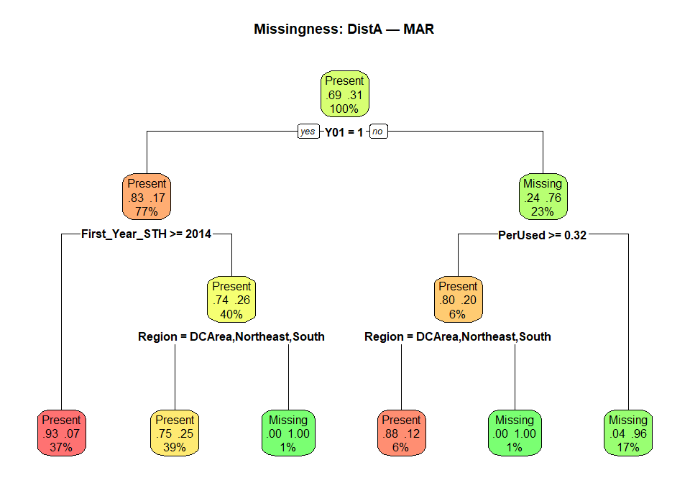
Observations:
- MAR (splits found): DistA, Most_Purch_Concession, missingness predicted by other variables.
- Likely MCAR (no splits): variables where missingness is unpredictable from observed data.
- 7 CustomerDF block variables: likely MNAR (customers who skipped the survey differ systematically). Imputed anyway to observe effect; interpret with caution.

MD Step 6: Simple (Univariate) Imputation
Handle variables with small missingness using simple methods before MICE. Management dictates stochastic (independent) imputation for Rep_Calls and Rep_Name, and regression-based imputation for Age.
Variable | % Missing | Method
Num_Children | 4.3% | Median
Rep_Visits | 5.4% | Median
Most_Purch_Concession | 0.9% | Mode
Sex | 7.1% | Mode
Rep_Calls | 4.6% | Mgmt Dictate — Stochastic (independent)
Rep_Name | 9.2% | Mgmt Dictate — Stochastic (independent)
Age | 10.4% | Mgmt Dictate — Regression (other vars)
Remaining 12 vars | 6–70% | → MICE (Step 7)
get_mode <- function(x) { x <- x[!is.na(x)]; ux <- unique(x); ux[which.max(tabulate(match(x, ux)))] }
# --- Median imputation ---
median_nc <- median(MDdf$Num_Children, na.rm=TRUE)
MDdf$Num_Children[is.na(MDdf$Num_Children)] <- median_nc
cat("Num_Children: imputed with median =", median_nc, "| NAs remaining:", sum(is.na(MDdf$Num_Children)), "\n")
## Num_Children: imputed with median = 1 | NAs remaining: 0
median_rv <- median(MDdf$Rep_Visits, na.rm=TRUE)
MDdf$Rep_Visits[is.na(MDdf$Rep_Visits)] <- median_rv
cat("Rep_Visits: imputed with median =", round(median_rv,2), "| NAs remaining:", sum(is.na(MDdf$Rep_Visits)), "\n\n")
## Rep_Visits: imputed with median = 13 | NAs remaining: 0
# --- Mode imputation ---
mode_mpc <- get_mode(MDdf$Most_Purch_Concession)
MDdf$Most_Purch_Concession[is.na(MDdf$Most_Purch_Concession)] <- mode_mpc
cat("Most_Purch_Concession: imputed with mode =", as.character(mode_mpc), "| NAs:", sum(is.na(MDdf$Most_Purch_Concession)), "\n")
## Most_Purch_Concession: imputed with mode = Beer | NAs: 0
mode_sex <- get_mode(MDdf$Sex)
MDdf$Sex[is.na(MDdf$Sex)] <- mode_sex
cat("Sex: imputed with mode =", as.character(mode_sex), "| NAs:", sum(is.na(MDdf$Sex)), "\n\n")
## Sex: imputed with mode = M | NAs: 0
# --- Mgmt Dictate: Stochastic (independent, sample with replacement) ---
set.seed(42)
observed_rc <- MDdf$Rep_Calls[!is.na(MDdf$Rep_Calls)]
MDdf$Rep_Calls[is.na(MDdf$Rep_Calls)] <- sample(observed_rc, sum(is.na(MDdf$Rep_Calls)), replace=TRUE)
cat("Rep_Calls: stochastic imputation | NAs:", sum(is.na(MDdf$Rep_Calls)), "\n")
## Rep_Calls: stochastic imputation | NAs: 0
set.seed(123)
observed_rn <- MDdf$Rep_Name[!is.na(MDdf$Rep_Name)]
level_props <- prop.table(table(observed_rn))
MDdf$Rep_Name[is.na(MDdf$Rep_Name)] <- sample(names(level_props), sum(is.na(MDdf$Rep_Name)),
replace=TRUE, prob=as.numeric(level_props))
cat("Rep_Name: stochastic imputation (proportional) | NAs:", sum(is.na(MDdf$Rep_Name)), "\n")
## Rep_Name: stochastic imputation (proportional) | NAs: 0
# --- Mgmt Dictate: Age via linear regression on other variables ---
age_predictors <- c("Y01","Total_Spent","NumSeats","Tenure","First_Year_STH",
"Num_Children","Rep_Calls","Rep_Visits","Concession_Total","Survey_Comp")
available_preds <- age_predictors[sapply(age_predictors, function(v) v %in% names(MDdf) && sum(is.na(MDdf[[v]]))==0)]
train_idx <- !is.na(MDdf$Age)
age_model <- lm(Age ~ ., data=MDdf[train_idx, c("Age", available_preds)])
pred_age <- predict(age_model, newdata=MDdf[!train_idx, available_preds])
pred_age <- pmin(pmax(round(pred_age), min(MDdf$Age, na.rm=TRUE)), max(MDdf$Age, na.rm=TRUE))
MDdf$Age[!train_idx] <- pred_age
cat("Age: regression imputation (", length(available_preds), "predictors) | NAs:", sum(is.na(MDdf$Age)), "\n")
## Age: regression imputation ( 9 predictors) | NAs: 0
cat("Predicted Age — Mean:", round(mean(pred_age),1), "| SD:", round(sd(pred_age),1),
"| Range:", min(pred_age), "-", max(pred_age), "\n")
## Predicted Age — Mean: 61.7 | SD: 12.7 | Range: 18 - 98

Summary: MD Steps 1–6
Step | Action | Key Finding
1. Identify | Count & table all missing data | 12.2% overall; 7-variable block at 70%
2. Mark | Create M_ indicator variables | Block pattern confirmed (r = 1.0)
3. Clean | Cap Survey_Comp; keep Marital “U” | 110 values corrected
4. Decide | Define exclude list; keep all variables | No rows or analytical vars excluded
5. Assess | Decision trees on M_ indicators | Mix of MAR, MCAR, MNAR (block)
6. Impute | Median (2), Mode (2), Stochastic (2), Regression (1) | 7 variables resolved; 12 go to MICE

